Inverse Filtering

# MATLAB code for inverse filtering:

filename = 'synthetic.wav';

[s Fs] = audioread(filename);

N = size(s,1);

[av ag al] = gfmiaif(s,18,3);

sys = tf(1,ag,1/Fs,'Variable','z^-1');

impulse(sys)

The function gfmiaif is from <https://github.com/operrotin/GFM-IAIF>. It takes a speech sample and returns linear prediction coefficients for the glottal filter, vocal tract filter and radiation from the lips using iterative adaptive inverse filtering (IAIF) methods.

# ****Glottal Volume Velocity Waveforms****

The glottal volume velocity waveform $u_{G}[n]$ is the response of the glottal filter $G(z)$ to an impulse train. One period of $u_{G}[n]$ can be approximated with the impulse response of $G(z)$.

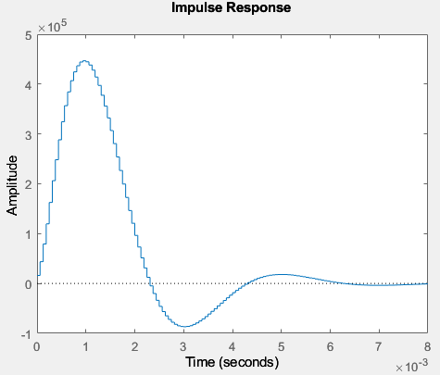 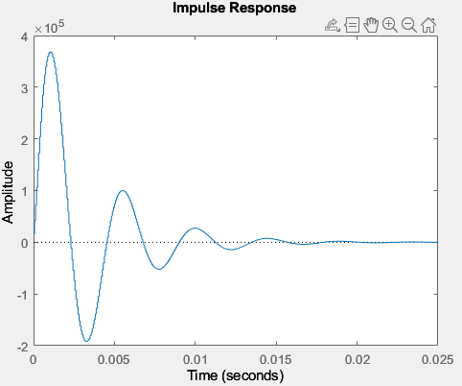

*Natural vowel sound Synthetic vowel sound*

Need to check this with a better dataset with the same vowel sounds.